I have did some admin work on the site please check.

- Posted a new dummy blog post.

I have posted a dummy blog post :



- Created a publisher user.

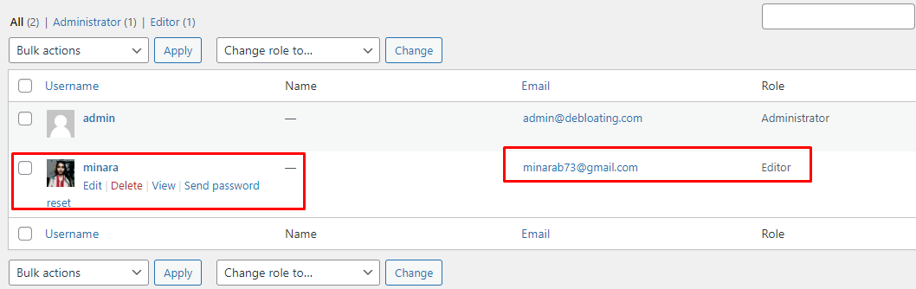

- Enabled Captcha on admin login.

I used a plugin to do it : <https://wordpress.org/plugins/login-recaptcha/>

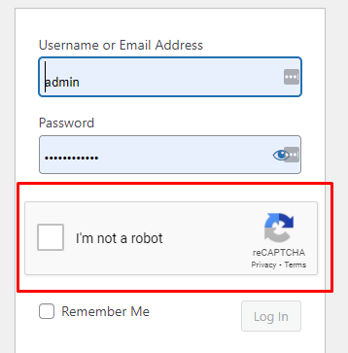

- Installed and customized a new theme.

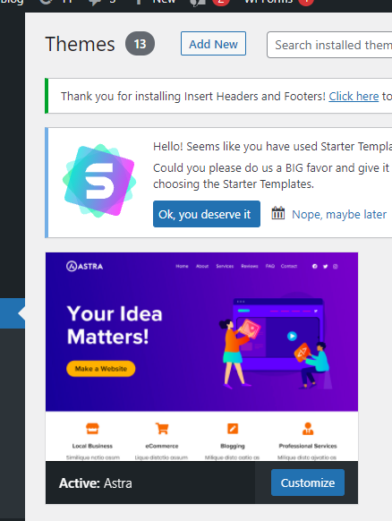

You can see the customization here: <https://wordpress099.websiteusage.xyz/>

- Improved SEO.

For improve seo we can use this plugin I installed it into backend

<https://wordpress.org/plugins/wordpress-seo/>

- Exported WP data for backup.

For backup and export data I use this plugin: <https://wordpress.org/plugins/all-in-one-wp-migration/>

